C:\STOCKLAYOUTS\CURRENT PROJECTS\FN99803-PL\FN99803-IMG02.emf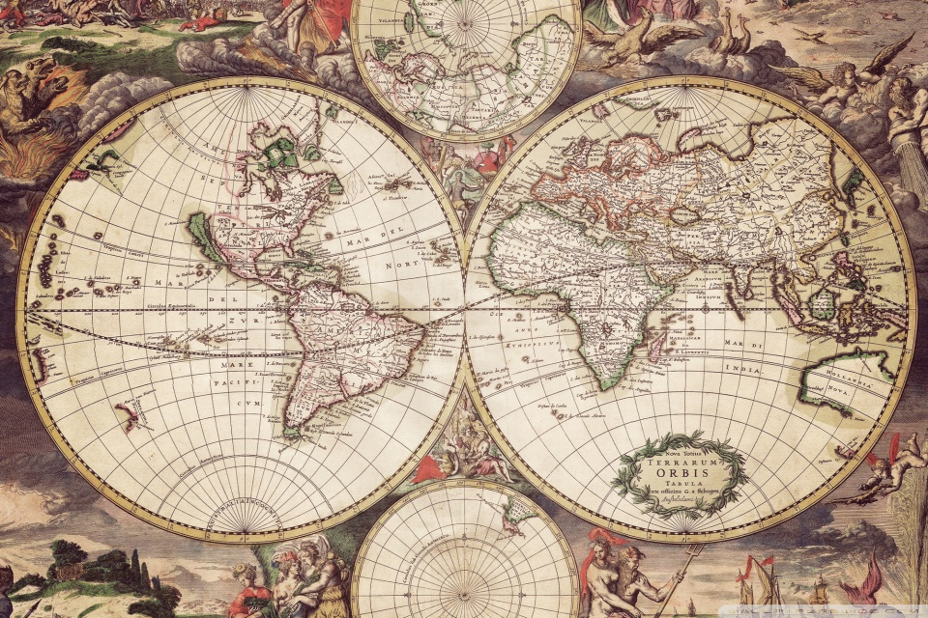C:\STOCKLAYOUTS\CURRENT PROJECTS\FN99803-PL\FN99803-IMG10.emf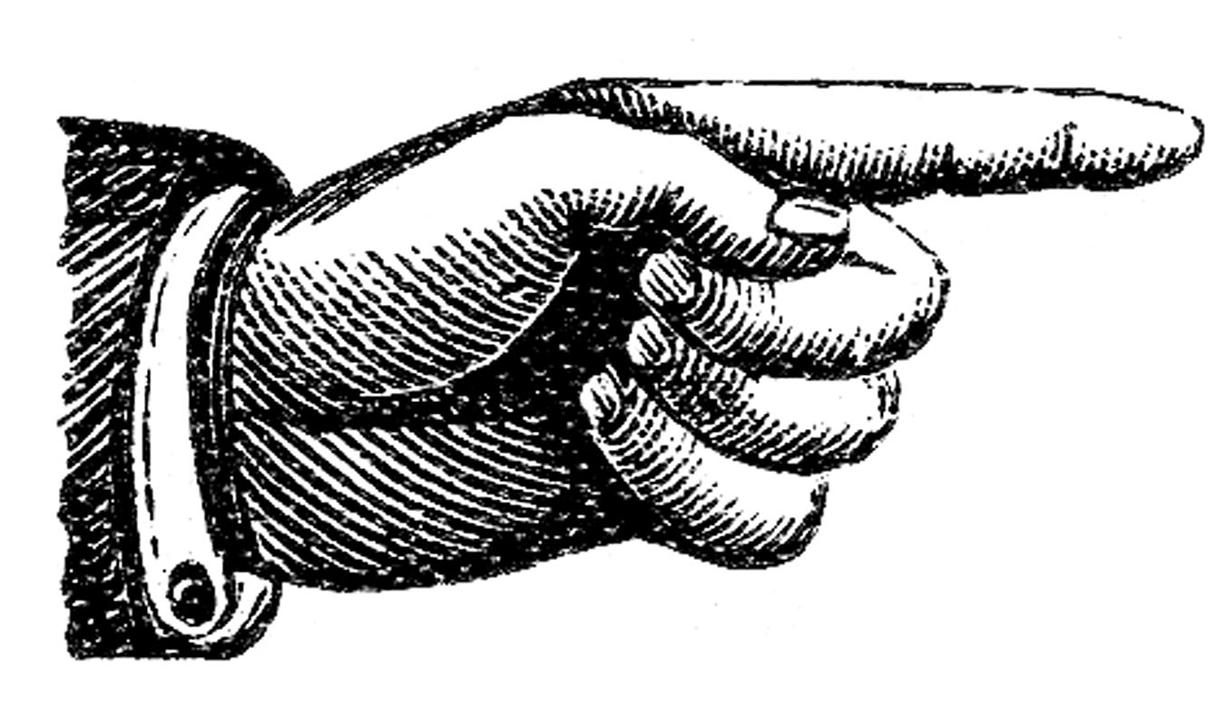C:\STOCKLAYOUTS\CURRENT PROJECTS\FN99803-PL\FN99803-IMG01.emf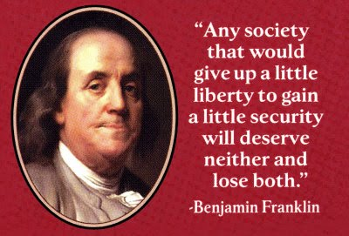

**WELCOME!**

I would like to start off by letting you know this is not a data dump class. The subject of History is loaded with valuable information but trying to conquer the vast expanse of the past in its entirety with fewer than 200 days would be inconceivable! It is our goal in this room to sort through the important questions that we, as historians, have about the past. Not only will we utilize the text book to answer these questions, we will also view films, listen to music, analyze images and examine primary source documents in order to investigate the past in an authentic setting. My goal is that you will leave this room as knowledgeable individuals with questioning minds and the ability to scrutinize any and all accepted truths. By questioning the past, you will discover your voice and your values.

**EThOS MISSION STATEMENT:**

The mission of the Thousand Oaks High School EThOS Entrepreneurship Academy is to educate a diverse and motivated student population by providing a challenging program with a business and entrepreneurial focus, opportunities for business and community involvement, and a model for responsible lifelong learning with an emphasis on post-secondary career and education.

◆ 11th GRADE US HISTORY

10th GRADE WORLD HISTORY

12th GRADE GOVERNMENT

Mock Trial FAcilitator

tUTORING CENTER COORDINATOR

◆ **Contact Information**

Outlook Email for Parents:

[schase@conejousd.org](mailto:schase@conejousd.org)

Gmail for Students

[schase@learn.conejousd.net](mailto:schase@learn.conejousd.net)

Website:

tohschase.weebly.com

** Thousand Oaks High School**

2016-2017 School Year

Mrs. Chase

History

**ONLINE GOVERNMENT**

**MATERIALS**

**Course Text Book:** United States Government: Democracy in Action. McGraw Hill.

**Recommended Materials:**

* 1 Inch Binder
* College Ruled Paper
* Pens
* 1 hole punched Folder

**US HISTORY**

**MATERIALS**

**Course Text Book:** The Americans: Reconstruction to the 21st Century. McDougal Littell.

**Recommended Materials:**

* 1 Inch Binder
* College Ruled Paper
* Pens
* Coloring Materials
* Scissors
* 1 Hole Punched Folder

**WORLD HISTORY**

**MATERIALS**

**Course Text Book:** World History, The Modern World. Ellis and Esler

**Recommended Materials:**

* 1 Inch Binder
* College Ruled Paper
* Pens (dark ink only)
* Coloring Materials
* Scissors
* 1 Hole Punched Folder

Grading Policy

I grade on a point scale. I do not weigh assignments. If the assignment, test or project is worth more for your grade it will be worth more points. Assignments will be submitted online and in class, please see the class website for assignment information, due dates and test dates.

**INVOICES:** Class assignments are recorded on invoices that will be stamped at random during class time. Each invoice, and all of the work listed, is due by the test date for that chapter /Unit. Invoices will be posted on the class website as we progress through a chapter/Unit.

Mrs. Chase

*EThOS*

C+ = 79.9%-78%

C = 77.9%-72%

C- = 71.9%-70%

D = 69.9%-60%

F = 59.9% or below

A+ = 100%-98%

A = 97.9%-92%

A- = 91.9%-90%

B+ = 89.9%-88%

B = 87.9%-82%

B- = 81.9%-80%

**Participation:**

Students will receive participation points for contributing to class discussions. Points can be taken away for being off task during class time. Cell phones are not needed during class time. Students have access to computers to do all classwork; if cell phones are needed, Mrs. Chase will let students know in advance.

**EXCUSED ABSENCES:**

Students will have as many days as their excused absence to

make up the work that they missed. If a student has an excused

absence for 3 days, they will have 3 days, starting the day they

return to class, to make up the work they missed. After that time

the assignments will be late. See **late work policy.**

Students who are **absent for** **tests** must email me and make an appointment to make up the

test. No walk-ins. If a student makes an appointment and fails to show up for the make-up

they will receive an automatic 0 on the test.

**UNEXCUSED ABSENCES:**

Students may not submit any work that they have missed during an unexcused absence. Please clear all absences through the office.

**SCHOOL SUSPENSION:**

Students can complete work that they miss during their suspension. Their work will be waiting in the office for them or they can access the information and assignments through the class website. Students have 24 hours starting the day they return to classes to submit all of the work that they missed. If students have any questions or confusion over the material they can email me at any time.

**LATE WORK POLICY:**

For all EThOS classes, your work is due on the date posted by the teacher at the START of class. If your work is late it will drop 50% of its value until the test for that unit. Any work that has not been submitted before the test for that chapter/unit will become a zero.

**BEHAVIOR:**

If a student is asked to leave class because of behavioral issues they are still responsible for any assignments given that day. Please see the stipulations for “School Suspension.”

**CLASS RULES:**

I have one golden rule that covers a multitude of classroom infractions:

**\*Show Respect and Think First.**

As members of the EThOS Academy I expect you to show respect by listening to your classmates and to me, not abusing the technology available to you, being kind to others and holding yourself to a higher standard on and off campus. I ask you to think first with all of your words and actions. If your words or actions cause harm or alienate others, your membership in the academy will be jeopardized. You are a member of a close knit academy and you are welcome to be yourself here as long as that coincides with respecting your fellow academy members and teachers. Please review the EThOS contract you signed at the beginning of the year to review expectations for participation and behavior.

**Cheating Policy:**

1st Infraction- Student caught cheating will receive a 0 on the assignment and the occurrence will be documented. Parents and Administration will also be notified.

***-Any homework completed on TurnItIn.com must be less than 20% plagiarized or it will receive a 0.***

**Lastly,**

Please remember that your classmates have the right to learn and I have the right to teach.

Every day in this room is a fresh start. We all have bad days so communication is key. I am always available to talk if you are having trouble or if you want to be more involved in the academy. I look forward to working with you.

Please see attached **Movie Waiver Form** and sign so students can view films in class. Return movie form with **signed syllabus receipt**.

Sincerely,

Mrs. Chase

STAMP